What are the genetic and molecular mechanisms underlying phenotypic differences within and between species and how did they evolve?
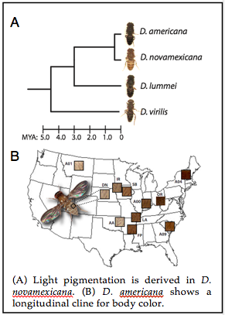
To address this question, we study D. americana and D. novamexicana, which are sister species in the virilis group of Drosophila that last shared a common ancestor approximately 380,000 years ago. D. americana has a brown body color similar to other members of this species group, whereas D. novamexicana has a uniquely derived yellow pigmentation (Figure A) (Wittkopp et al. 2003). Recently, we showed that body color is polymorphic within D. americana and varies along a longitudinal cline that appears to result from local adaptation (Figure B) (Wittkopp et al. 2011). This gives us the opportunity to compare the genetic basis of pigmentation differences that have evolved on multiple evolutionary timescales.
Thus far, we have shown that genetic variants linked to two genes that have opposing effects on pigment synthesis (tan and ebony) explain 87% of the pigmentation difference between these species; for both genes, species-specific alleles differ in cis-regulatory activity but not protein sequence; and functionally divergent sites are located within the first intron of tan (Wittkopp et al. 2009; Cooley et al. 2012). Surprisingly, the cis-regulatory divergence we observed for tan was limited to a 29% change in transcript abundance during a short window of developmental time, illustrating the functional importance of even small and temporally-dynamic changes in gene expression (Cooley et al. 2012).
Our genetic mapping of variation within D. americana showed that D. novamexicana-like alleles (in sequence and function) that appear to predate speciation are still segregating in some populations of D. americana (Wittkopp et al. 2009). This unexpected finding suggests that the derived phenotype of D. novamexicana evolved by selection on standing genetic variation, which addresses an ongoing debate about the source of adaptive alleles. Surprisingly, we found multiple genotypes underlying similar phenotypes within the same populations of D. americana, suggesting that genetic heterogeneity for pigmentation helps maintain allelic diversity. This work provides a rarely demonstrated link between phenotypic differences within and between species.
Current work in this area is focused on (1) further characterizing the genetic basis of polymorphic pigmentation within D. americana and (2) using transgenic analysis to identify the specific nucleotide changes responsible for differences in tan activity between D. americana and D. novamexicana. We are also interested in the links between pigmentation and behavior resulting from pleiotropy (Wittkopp and Beldade 2009).

Cooley A. M., Shefner L., McLaughlin W. N., Stewart E. E., Wittkopp P. J., 2012 The ontogeny of color: developmental origins of divergent pigmentation in Drosophila americana and D. novamexicana. Evol. Dev. 14: 317–325.
Wittkopp P. J., Beldade P., 2009 Development and evolution of insect pigmentation: genetic mechanisms and the potential consequences of pleiotropy. Semin. Cell Dev. Biol. 20: 65–71.
Wittkopp P. J., Smith-Winberry G., Arnold L. L., Thompson E. M., Cooley A. M., Yuan D. C., Song Q., McAllister B. F., 2011 Local adaptation for body color in Drosophila americana. Heredity (Edinb) 106: 592–602.
Wittkopp P. J., Stewart E. E., Arnold L. L., Neidert A. H., Haerum B. K., Thompson E. M., Akhras S., Smith-Winberry G., Shefner L., 2009 Intraspecific polymorphism to interspecific divergence: genetics of pigmentation in Drosophila. Science 326: 540–544.
Wittkopp P. J., Williams B. L., Selegue J. E., Carroll S. B., 2003 Drosophila pigmentation evolution: divergent genotypes underlying convergent phenotypes. Proc. Natl. Acad. Sci. U.S.A. 100: 1808–1813.

